**PRICES**

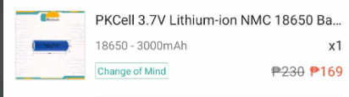

[**https://shp.ee/ql7i4y7**](https://shp.ee/ql7i4y7) **Price: 169**

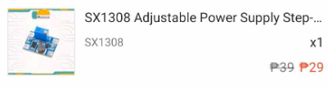

[**https://shp.ee/luz93su**](https://shp.ee/luz93su) **Price: 29**

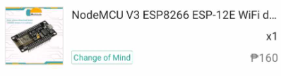

[**https://shp.ee/qqlc91o**](https://shp.ee/qqlc91o) **Price: 160**

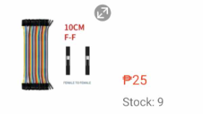

[**https://shp.ee/06y1ixq**](https://shp.ee/06y1ixq) **Price: 25**

**Shipping Fee: 35**

***TOTAL: 418***

**Explanation**

**Labels**

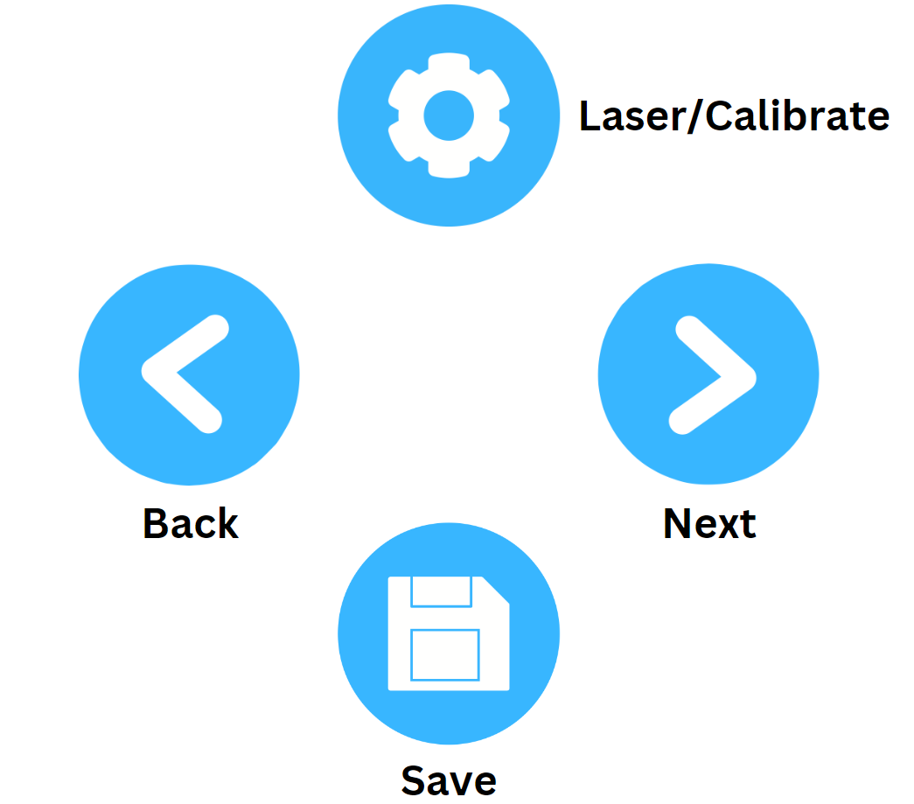

**Laser/Calibrate:**

* **(DISTANCE MODE)** For Laser press for 1 second to turn on and off
* **(ANGLE MODE)** For Calibrate press for 5 seconds to calibrate
  + When calibrating **PLACE IT IN A FLAT SURFACE** and wait for it to Finish

**Back/Next:**

* For Navigation

**Save:**

* If press for 1-3 seconds the last recorded data will be saved to the SD card
* The SD card has two excel file one for Distance and one for Angle

**Sensors used**

**Ultrasonic sensor:** for measuring distance, accuracy is (+-1cm to 2cm).

**MPU6050:** for measuring angle, not accurate need to calibrate every time there’s a better version for this the **MPU9250** heres the video reference for explanation:<https://www.youtube.com/watch?v=USa3HFLnrlk&t=298s>

**Boards**

**Arduino Nano:** The main board

**Node MCU ESP8266:** sapat na sana yung Arduino nano kaso kinukulang ng memory so ginamit ko tong nodeMCU para sa pag save ng info sa SD card Arduino nano din sana gagamitin ko kaso ang tagal dumating ng order ko kaya yung extra na nodemcu nalang yung ginamit ko since same lang naman sila ng magiging function.   
Here’s the reference kung bakit hindi pwede isama sdcard module sa Arduino Nano: <https://forum.arduino.cc/t/adding-an-sd-card-to-my-oled-project/607464>

**BUTTONS**

PWEDE NIYO PO ITO GAWING STICKERS AT IDIKIT SA TAPAT NG BUTTONS

I resize nalang po

